Docker Challenge-1
1). Create a customized Docker image using a Dockerfile.
- Create a project folder
mkdir my-docker-app
cd my-docker-app
- Create a sample file
Create an index.html file:
<!DOCTYPE html>
<html>
<head>
<title>This is My Custom Docker Image</title>
</head>
<body>
<h1>Hello from my customized Docker image</h1>
</body>
</html>
What is this?
- Create a Dockerfile
Create a file named Dockerfile:
FROM nginx:latest
LABEL maintainer="your-name"
COPY index.html /usr/share/nginx/html/index.html
EXPOSE 80
- Build the Docker image
docker build -t my-nginx-app:v1 .
- Check the image
docker images
You should see:
my-nginx-app v1
- Run the container
docker run -d -p 8094:80 --name nginx-container my-nginx-app:v1
- Verify it is running
docker ps
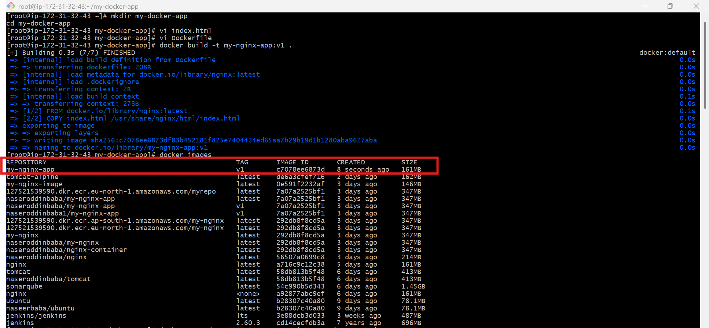
- Open in browser
Open: http://13.60.105.21:8094
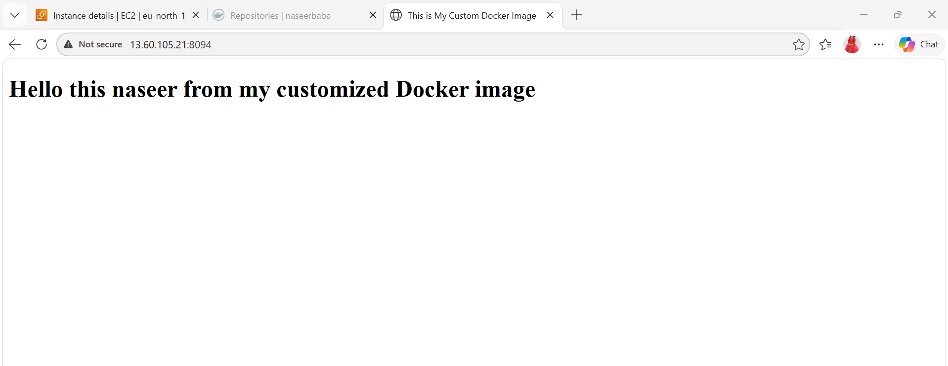
2). Push the image to Docker Hub.
Login to Docker Hub
Run this command in your terminal:
docker login
Enter:
- Username
- Password
You should see: Login Succeeded
- Check Your Local Images
docker images
- Tag the Image
You must tag your image with your Docker Hub username.
docker tag my-nginx-app:v1 naseerbaba/my-nginx-app:v1
- Push the Image
docker push naseerbaba/my-nginx-app:v1
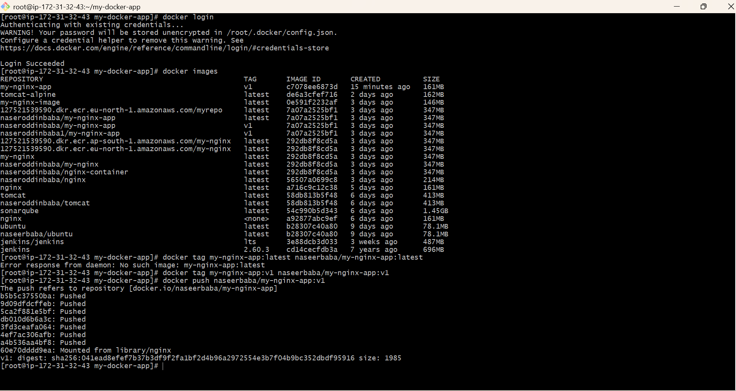
- Verify on Docker Hub
Go to: https://hub.docker.com/
Login and check your repository — your image should appear there.

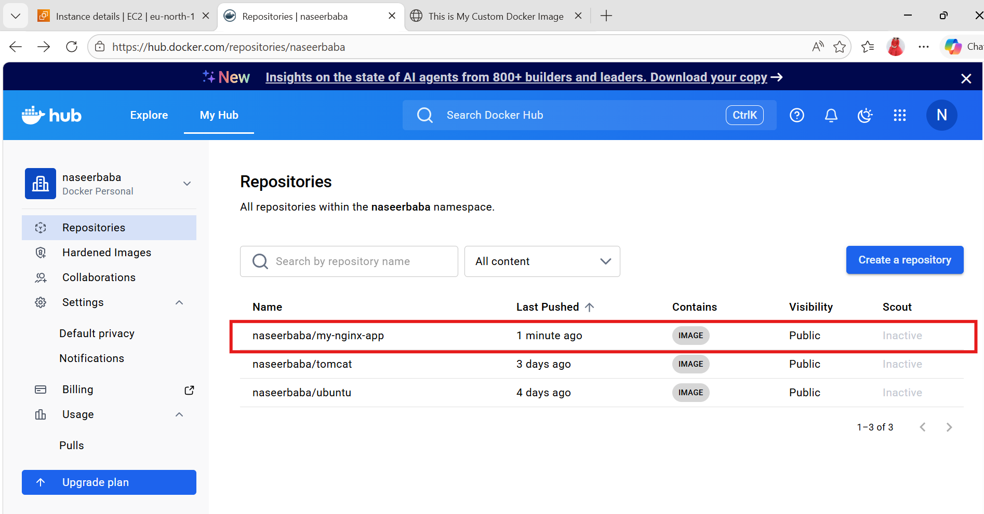

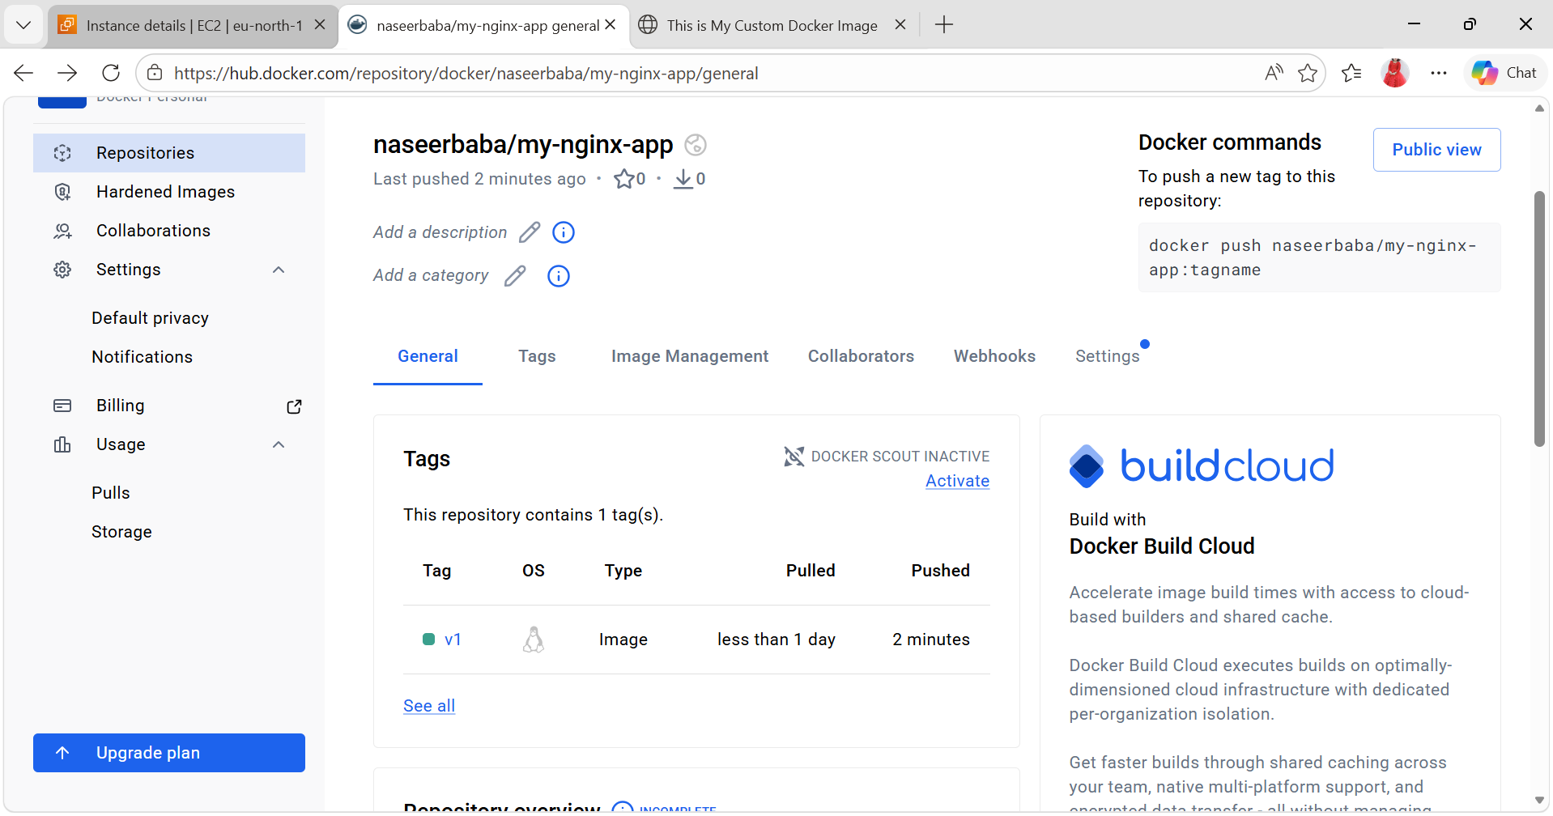
3). Push the same image to Amazon ECR.
- Configure AWS CLI
aws configure
Enter:
- Access Key
- Secret Key
- Region (example: eu-north-1)
- Output format: json
- Create ECR Repository
aws ecr create-repository \
--repository-name my-nginx-app \
--region eu-north-1
You will get a repository URI like:
127521539590.dkr.ecr.eu-north-1.amazonaws.com/my-nginx-app
- Login to Amazon ECR
Use this command:
aws ecr get-login-password --region eu-north-1 | \
docker login --username AWS \
--password-stdin 127521539590.dkr.ecr.eu-north-1.amazonaws.com
- Tag Your Docker Image
Tag your local image to ECR format:
docker tag my-nginx-app:v1 \
127521539590.dkr.ecr.eu-north-1.amazonaws.com/my-nginx-app:v1
- Push Image to ECR
docker push 127521539590.dkr.ecr.eu-north-1.amazonaws.com/my-nginx-app:v1
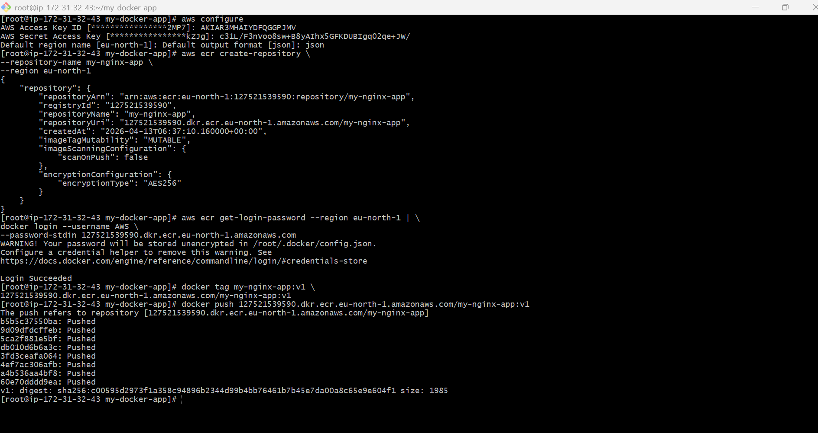

- Verify in AWS Console
Go to:
Amazon ECR
- Open repository → my-nginx-app
- Check image v1

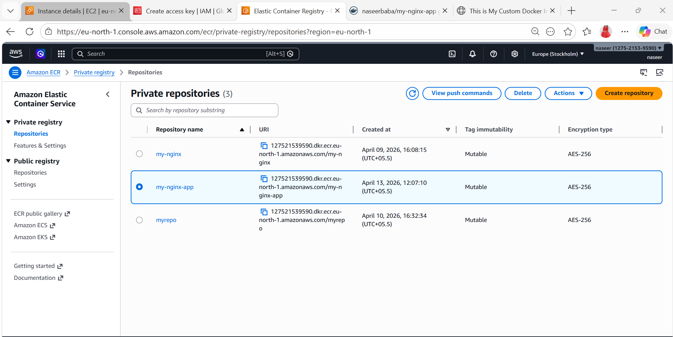
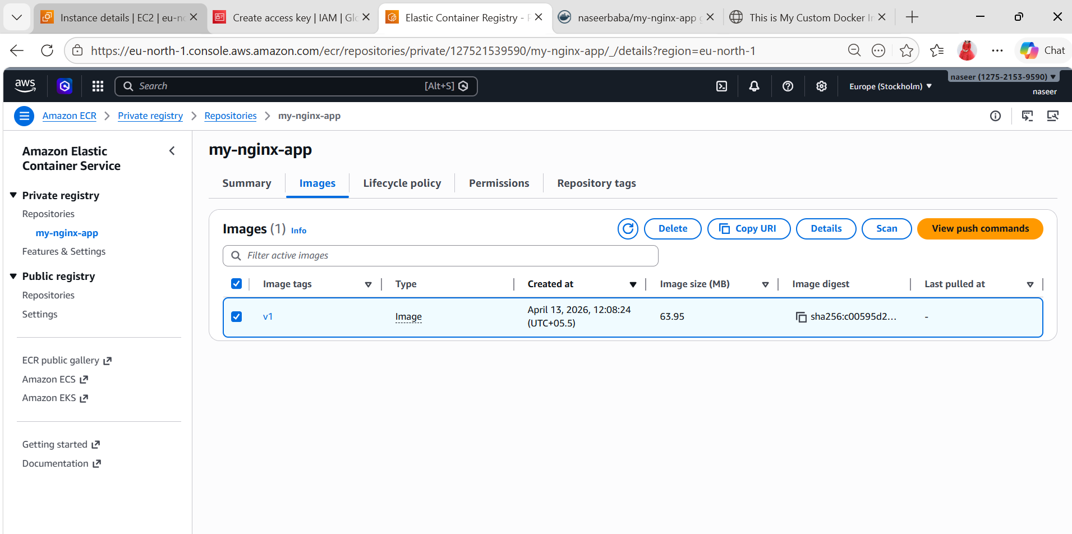

4). Provision one EC2 instance using Terraform and install Jenkins.
Pre-requisite:
Step-by-Step Install Terraform
Install required packages
sudo yum install -y yum-utils
Add HashiCorp repo
sudo yum-config-manager --add-repo https://rpm.releases.hashicorp.com/AmazonLinux/hashicorp.repo
Install Terraform
sudo yum install terraform -y
Verify Installation
terraform -version
Output should be like:
Terraform v1.x.x
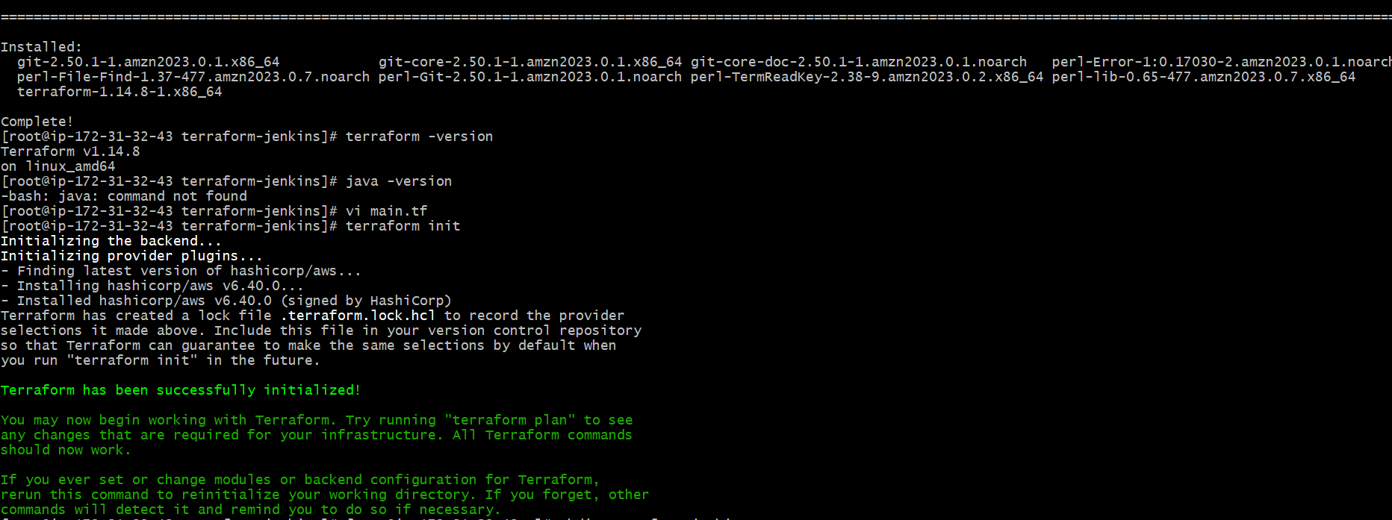

- Create Project Folder
mkdir terraform-jenkins
cd terraform-jenkins
- Create main.tf (Correct & Complete)
Your code is good, but missing security group resource + some fixes. Use this:
provider "aws" {
region = "eu-north-1"
}
# 🔐 Security Group
resource "aws_security_group" "jenkins_sg" {
name = "jenkins-sg"
description = "Allow SSH and Jenkins"
ingress {
from_port = 22
to_port = 22
protocol = "tcp"
cidr_blocks = ["0.0.0.0/0"]
}
ingress {
from_port = 8080
to_port = 8080
protocol = "tcp"
cidr_blocks = ["0.0.0.0/0"]
}
# ✅ Add this (IMPORTANT)
egress {
from_port = 0
to_port = 0
protocol = "-1"
cidr_blocks = ["0.0.0.0/0"]
}
}
# 🖥 EC2 Instance
resource "aws_instance" "jenkins_server" {
ami = " ami-077d1b9f9a1902bbc"
instance_type = "t3.micro"
key_name = "key.jenkins"
# ✅ BEST PRACTICE (instead of security_groups)
vpc_security_group_ids = [aws_security_group.jenkins_sg.id]
user_data = <<-EOF
#!/bin/bash
apt update -y
apt install -y openjdk-17-jdk wget
wget -q -O - https://pkg.jenkins.io/debian/jenkins.io.key | apt-key add -
sh -c 'echo deb http://pkg.jenkins.io/debian-stable binary/ > /etc/apt/sources.list.d/jenkins.list'
apt update -y
apt install -y jenkins
systemctl start jenkins
systemctl enable jenkins
EOF
tags = {
Name = "Jenkins-Server"
}
}
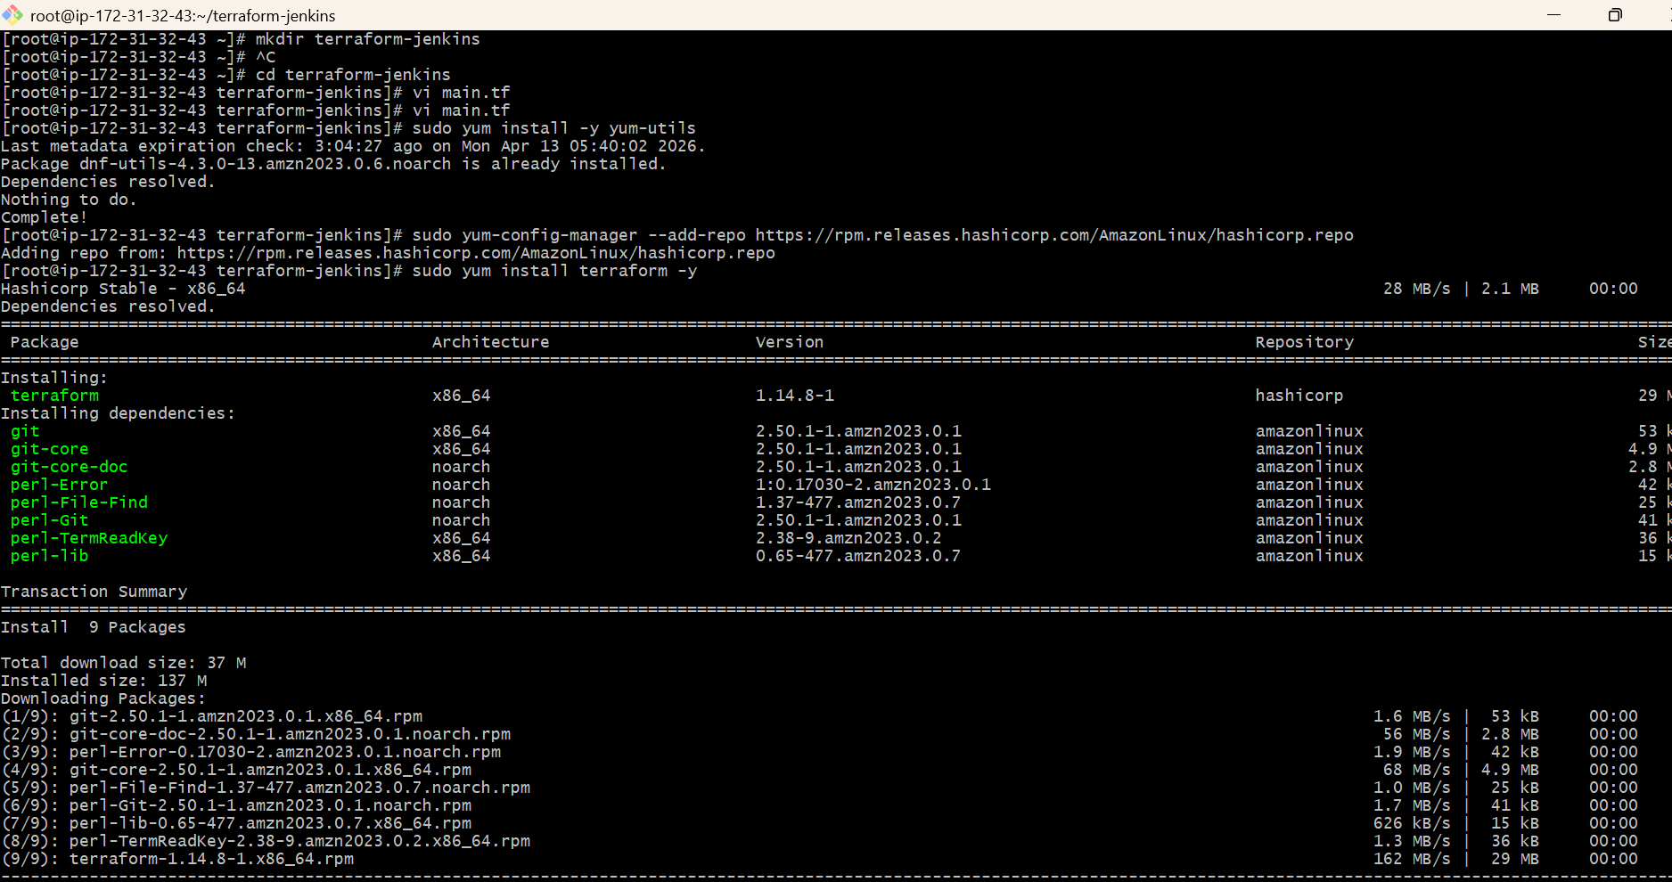
terraform init
terraform apply
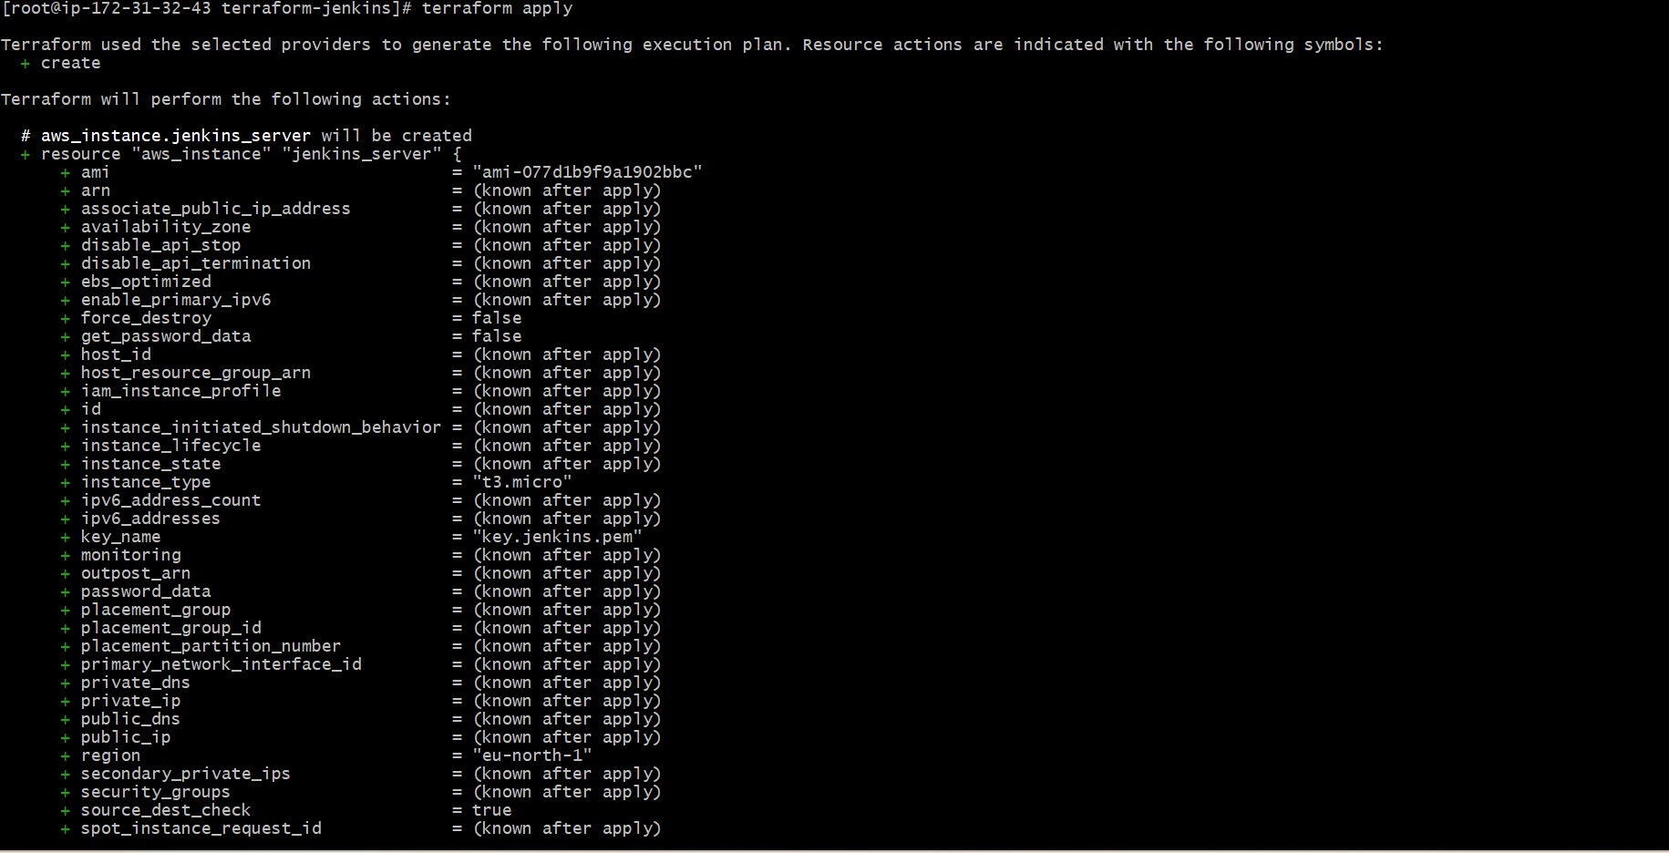
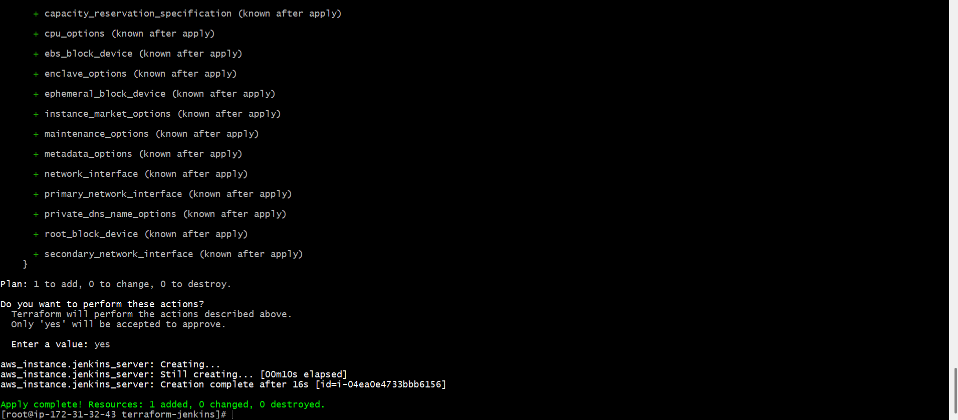
Check in ec2 : the new ec2 server Jenkins-server is launched and running stage and connect it and check for Jenkins is already installed.
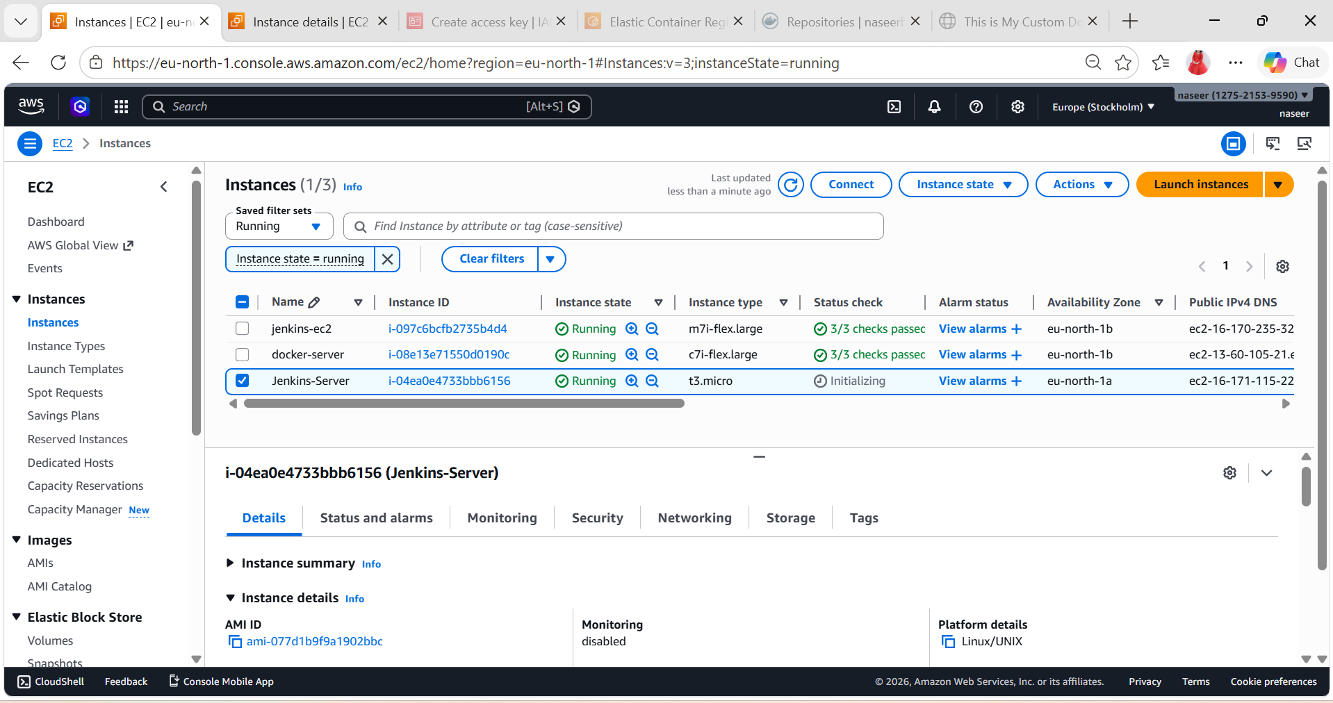
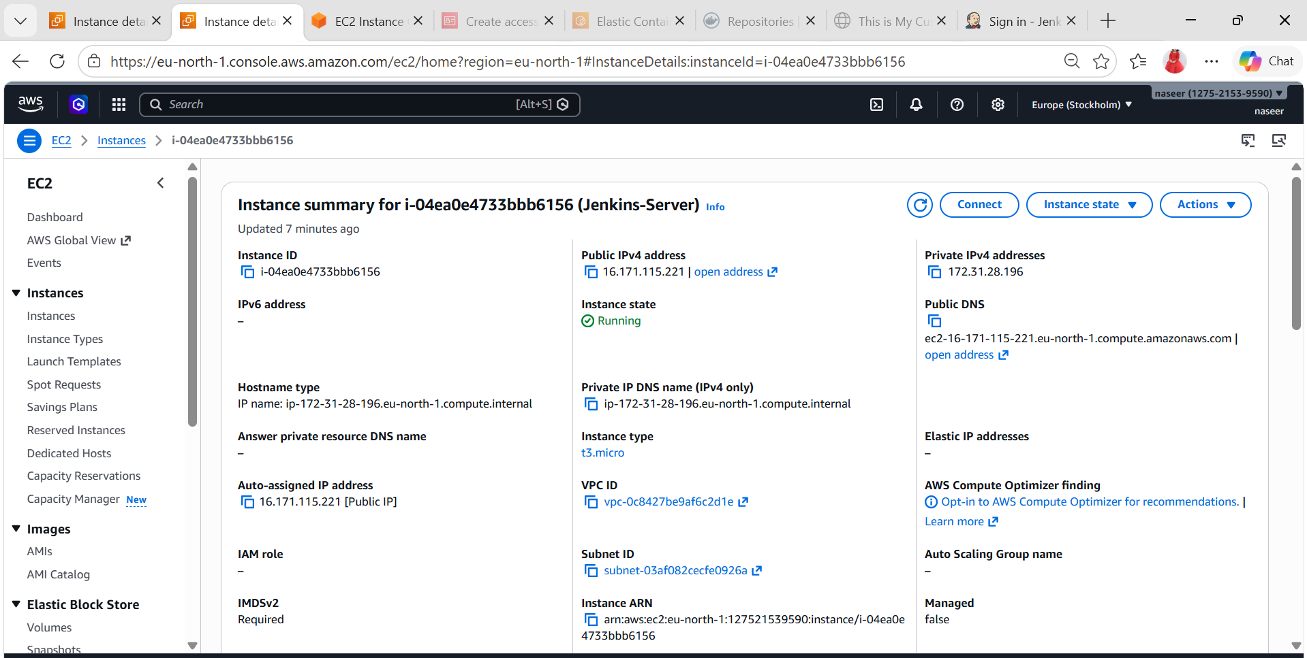
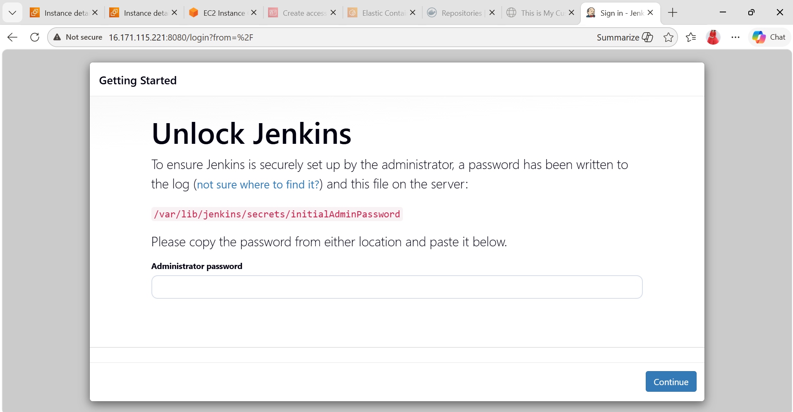
5). Create one Jenkins job to build and push the Docker image to Docker Hub.
- Source: https://github.com/betawins/Python-app.git
- Prerequisites
Before creating the job, make sure:
- Jenkins is installed & running
- Docker is installed on Jenkins server
- Jenkins user has Docker permission:
sudo usermod -aG docker jenkins
sudo systemctl restart jenkins
- Docker Hub account ready
- Install Required Plugin
In Jenkins: Manage Jenkins → Plugins → Install
- Docker Pipeline Plugin
This plugin allows Jenkins to build and push Docker images
- Add Docker Hub Credentials in Jenkins
Manage Jenkins → Credentials → Global → Add Credentials
Fill:
- Username: your Docker Hub username
- Password: your Docker Hub password
- ID: dockerhub-cred
- Create Jenkins Job
Dashboard → New Item
- Name: Jenkins-dockerhub
- Select: Pipeline
- Click OK
Add Pipeline Script
pipeline {
agent any
environment {
DOCKER_IMAGE = "naseerbaba/python-app:v1"
}
stages {
stage('Clone Code') {
steps {
git branch: 'main', url: 'https://github.com/betawins/Python-app.git'
}
}
stage('Build Docker Image') {
steps {
sh 'docker build -t $DOCKER_IMAGE .'
}
}
stage('Login to Docker Hub') {
steps {
withCredentials([usernamePassword(
credentialsId: 'dockerhub-creds',
usernameVariable: 'DOCKER_USER',
passwordVariable: 'DOCKER_PASS'
)]) {
sh '''
echo "Logging in as $DOCKER_USER"
echo "$DOCKER_PASS" | docker login -u "$DOCKER_USER" --password-stdin
'''
}
}
}

stage('Push Image to Docker Hub') {
steps {
sh 'docker push $DOCKER_IMAGE'
}
}
}
post {
success {
echo '✅ SUCCESS: Image pushed to Docker Hub'
}
failure {
echo '❌ FAILURE: Check logs'
}
}
}
- Build the Job
Click Build Now
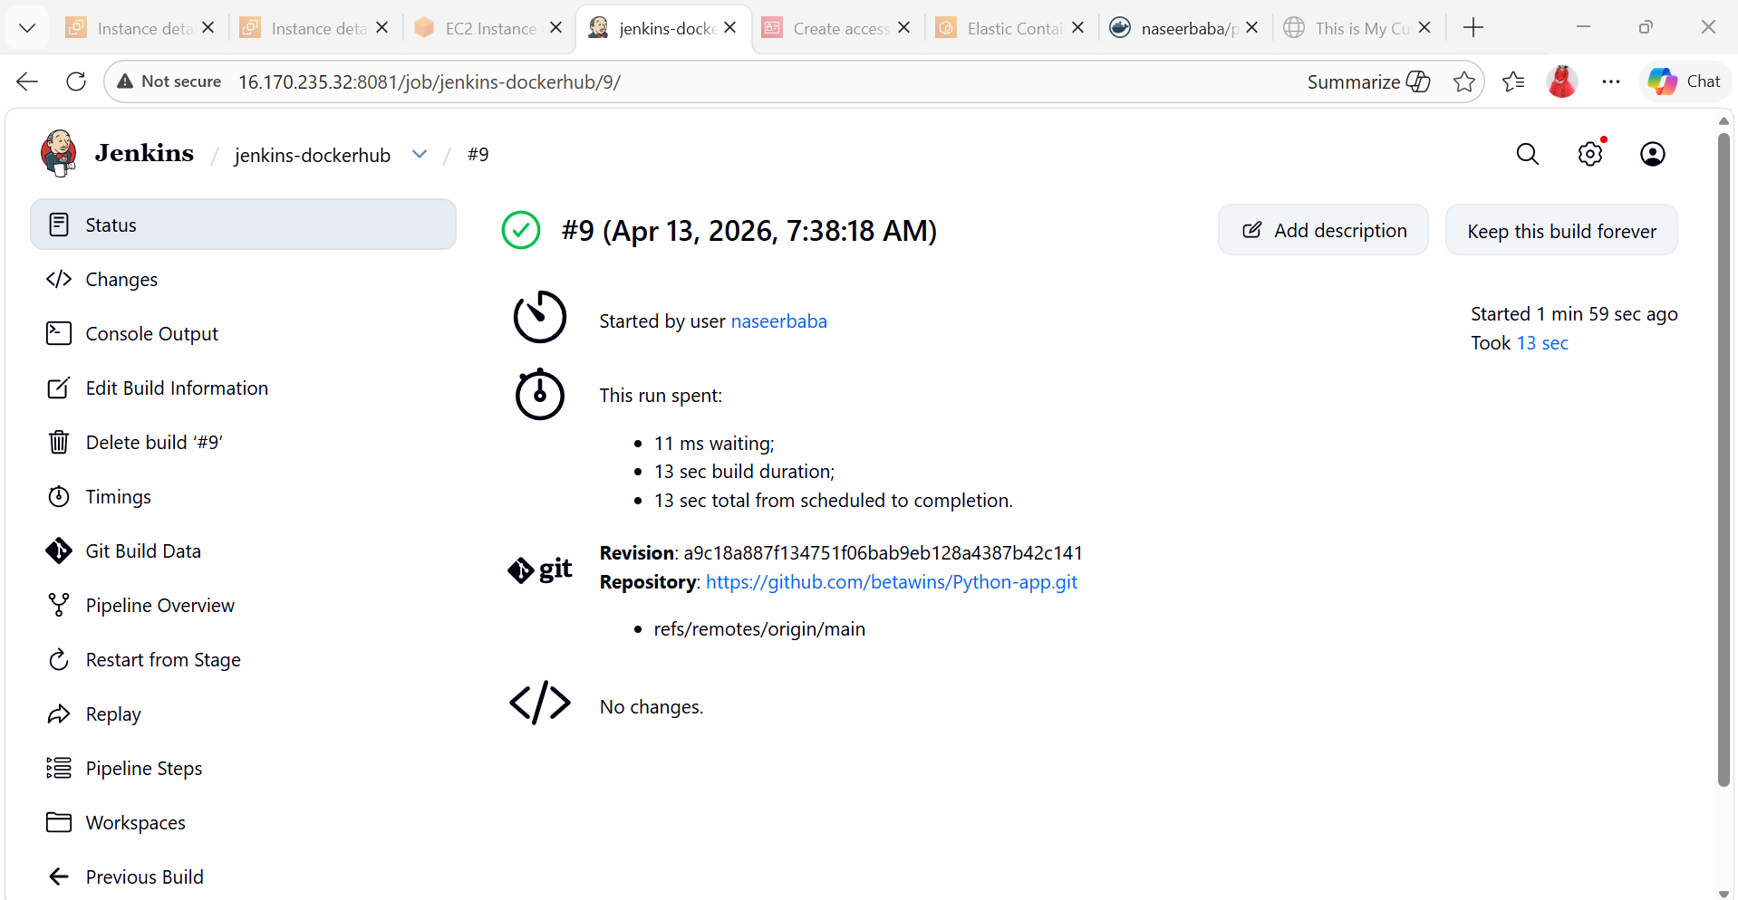
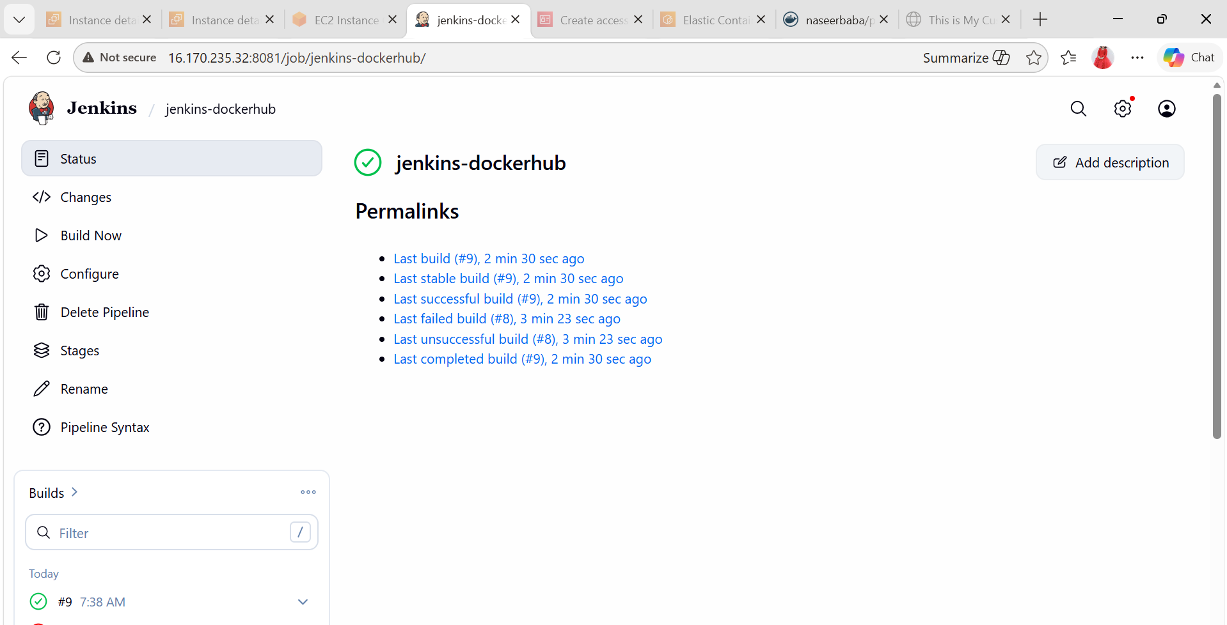
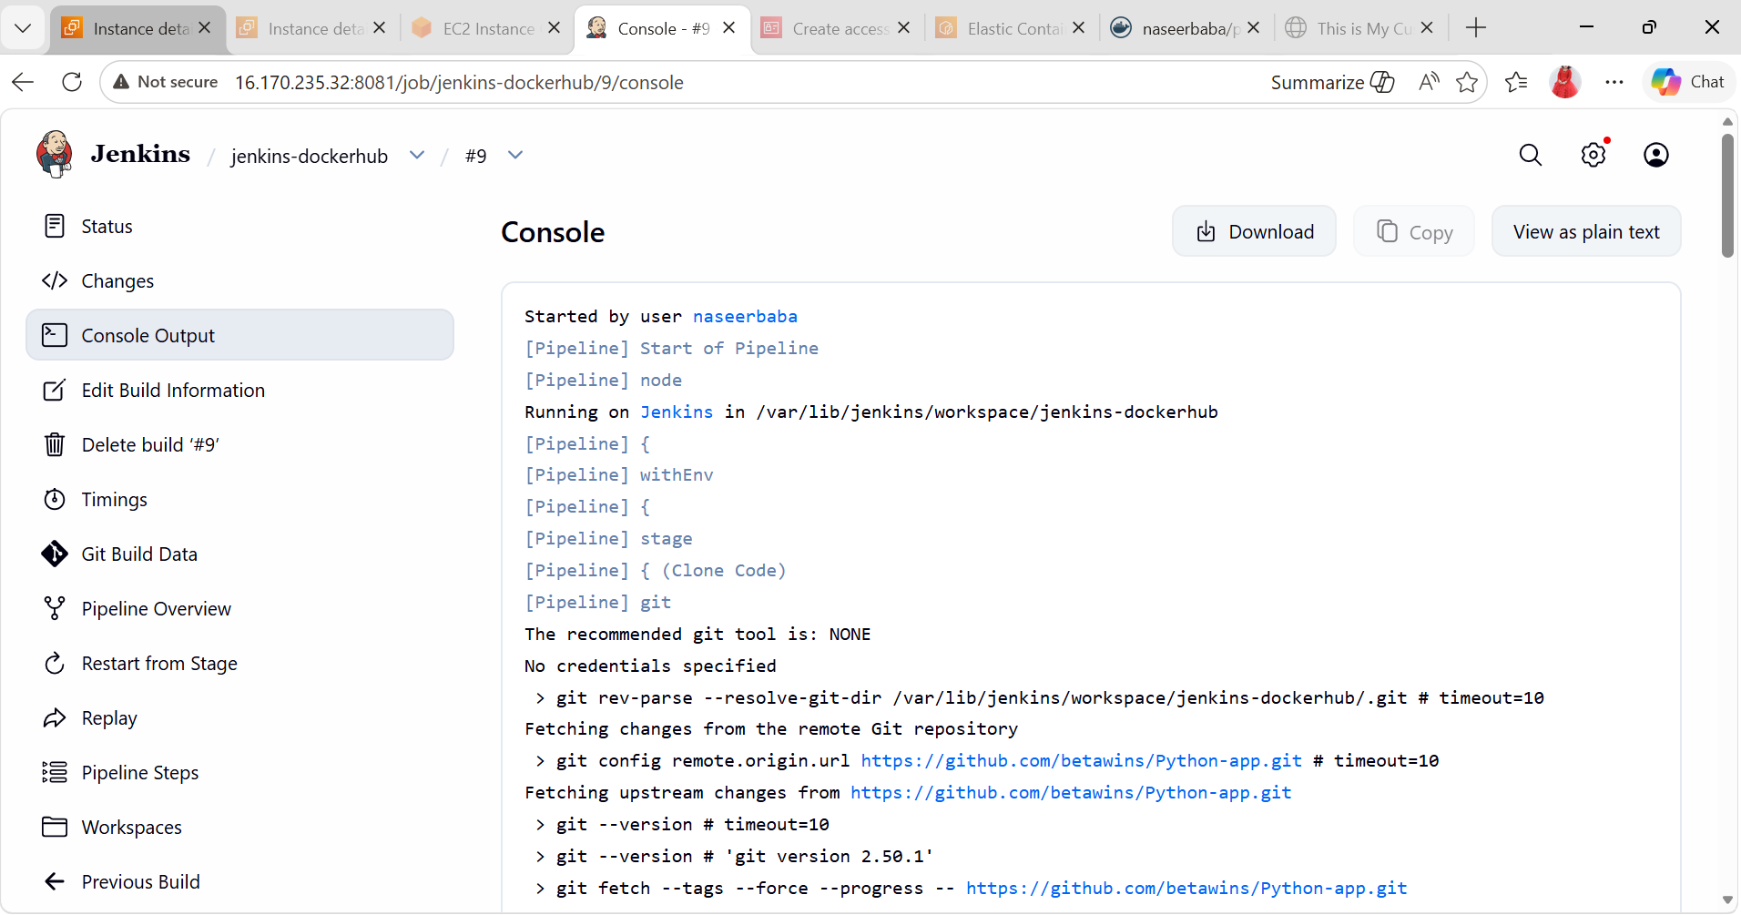
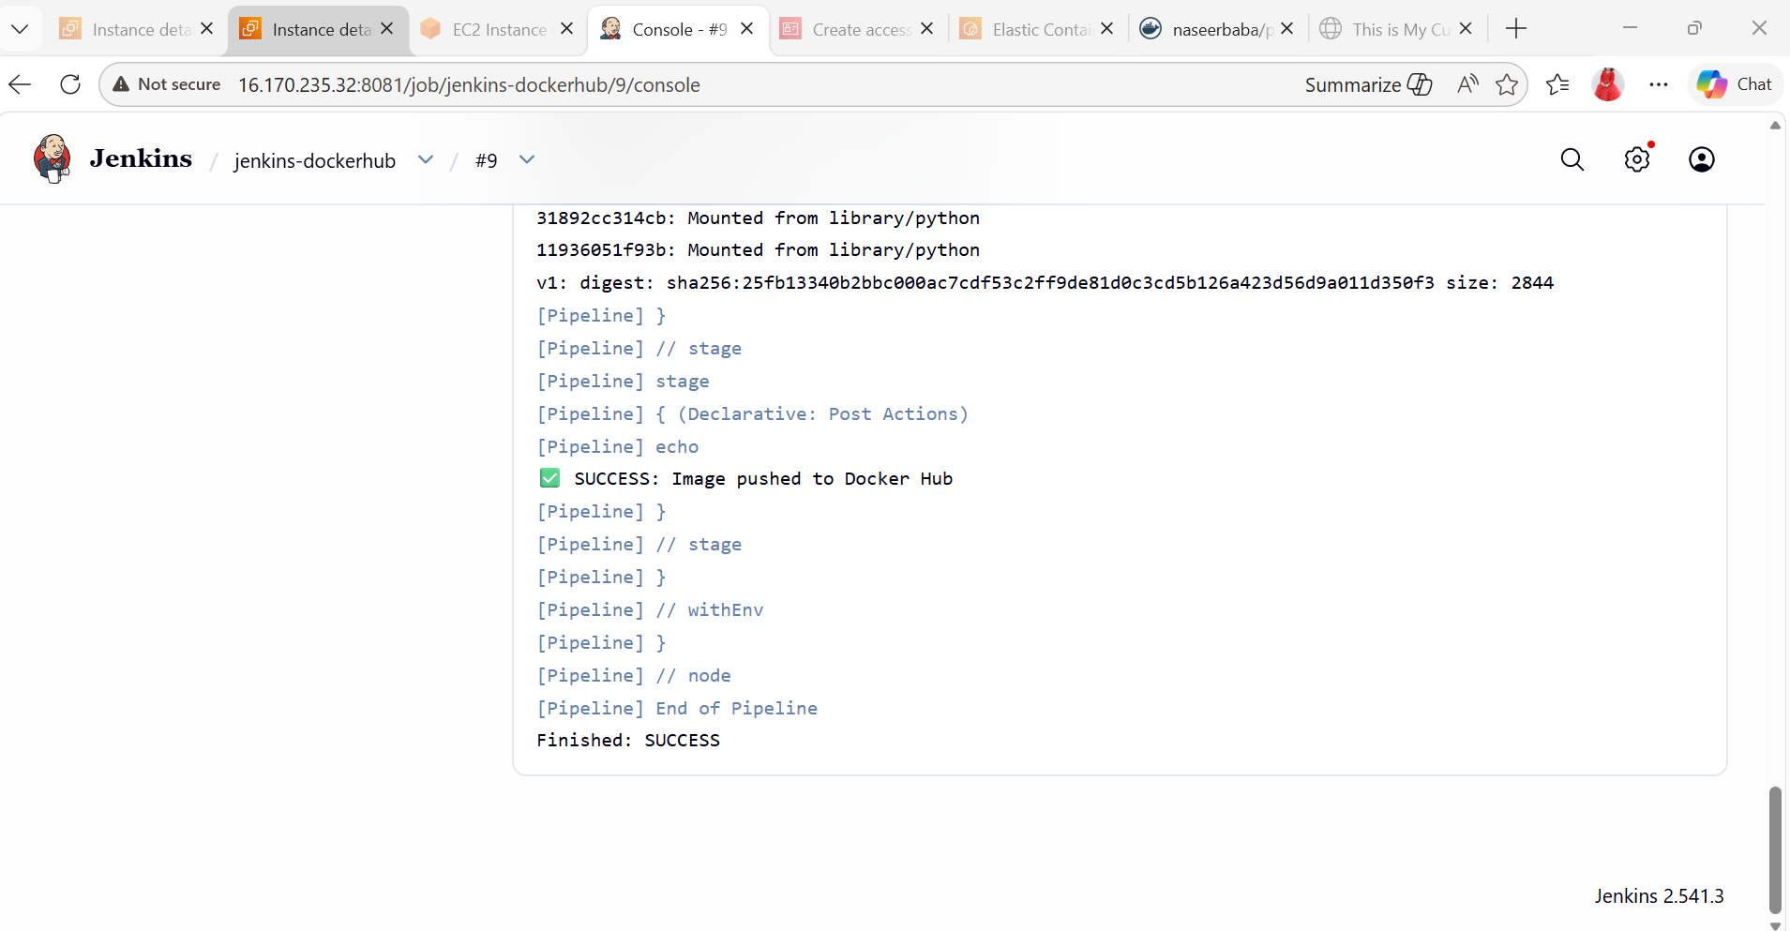
- Verify
Go to Docker Hub:
https://hub.docker.com
You should see:
python-app:v1

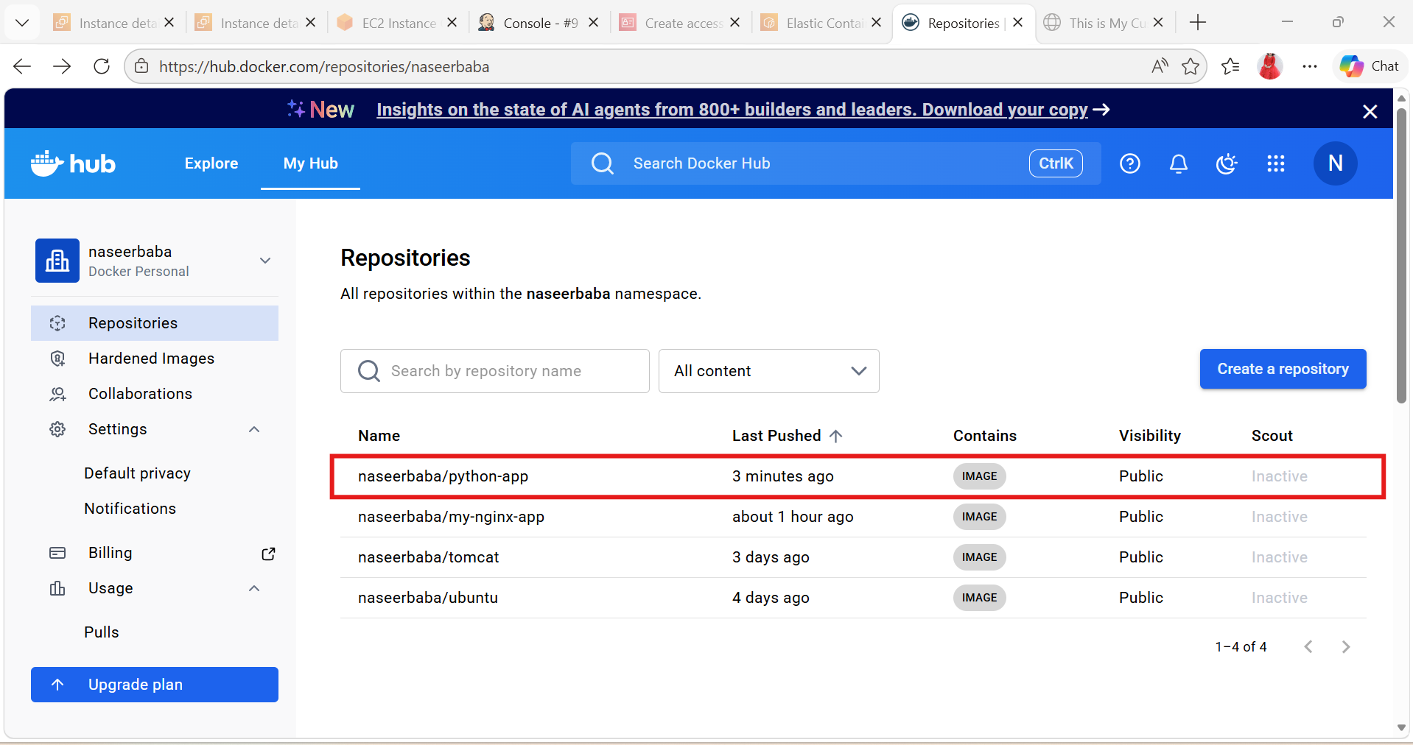
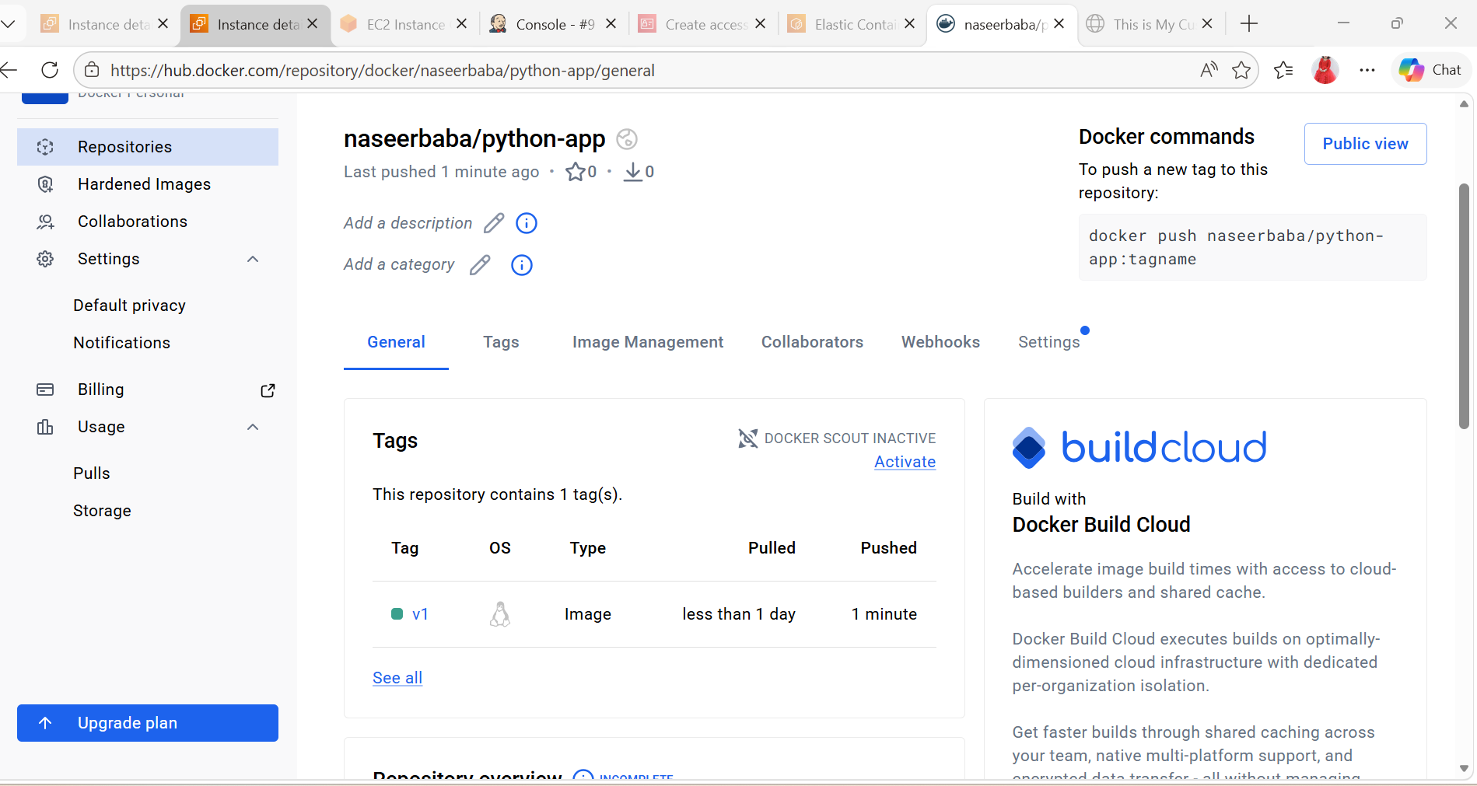
Source Codes: https://github.com/betawins/docker-tasks.git
6). From the frontend source code, write a Dockerfile, build a Docker image, run it, and push that image to your Docker registry.
- Clone the repository
git clone https://github.com/betawins/docker-tasks.git
cd docker-tasks/Frontend_based_source
This is the correct folder for the frontend files.
- Create the Dockerfile
vi Dockerfile
Paste:
FROM nginx:alpine
WORKDIR /usr/share/nginx/html
RUN rm -rf ./*
COPY . /usr/share/nginx/html/
EXPOSE 80
CMD ["nginx", "-g", "daemon off;"]
- Build the Docker image
docker build -t naseerbaba/frontend-app:v1 .
- Run the container
docker run -d -p 8080:80 --name frontend-container naseerbaba/frontend-app:v1
- Verify it is running
docker ps
- Login to Docker Hub
docker login
Enter your Docker Hub username and password.
- Push the image to Docker Hub
docker push naseerbaba/frontend-app:v1

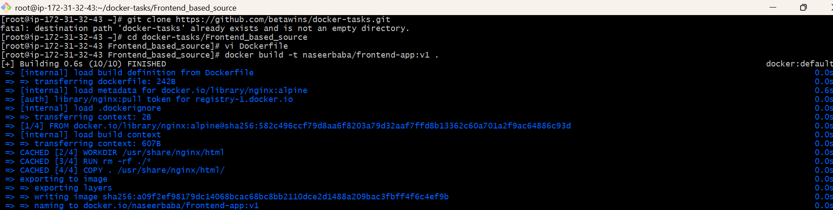
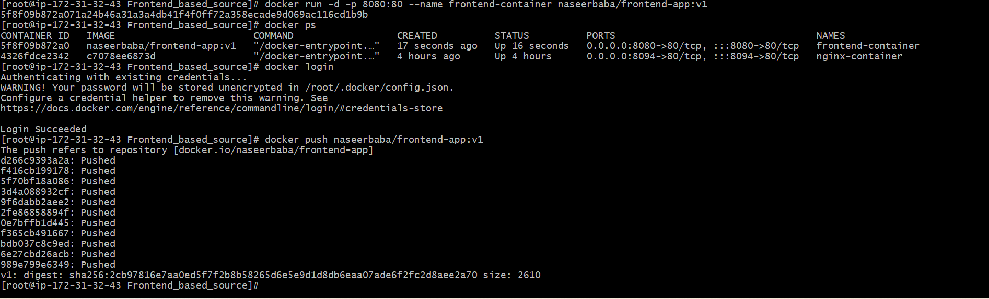
Open in browser:
http://13.60.105.21:8080

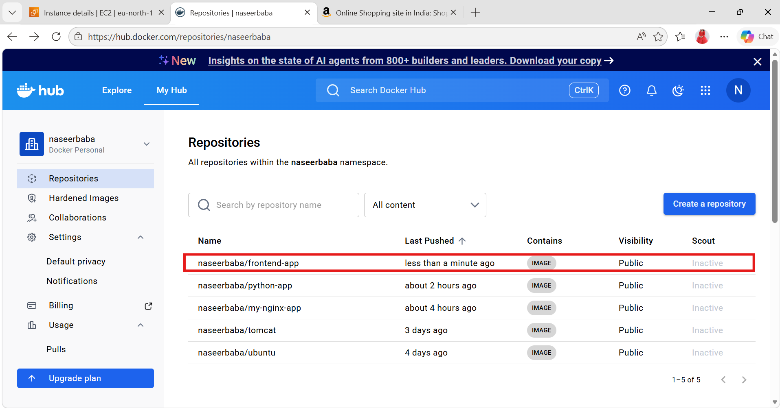

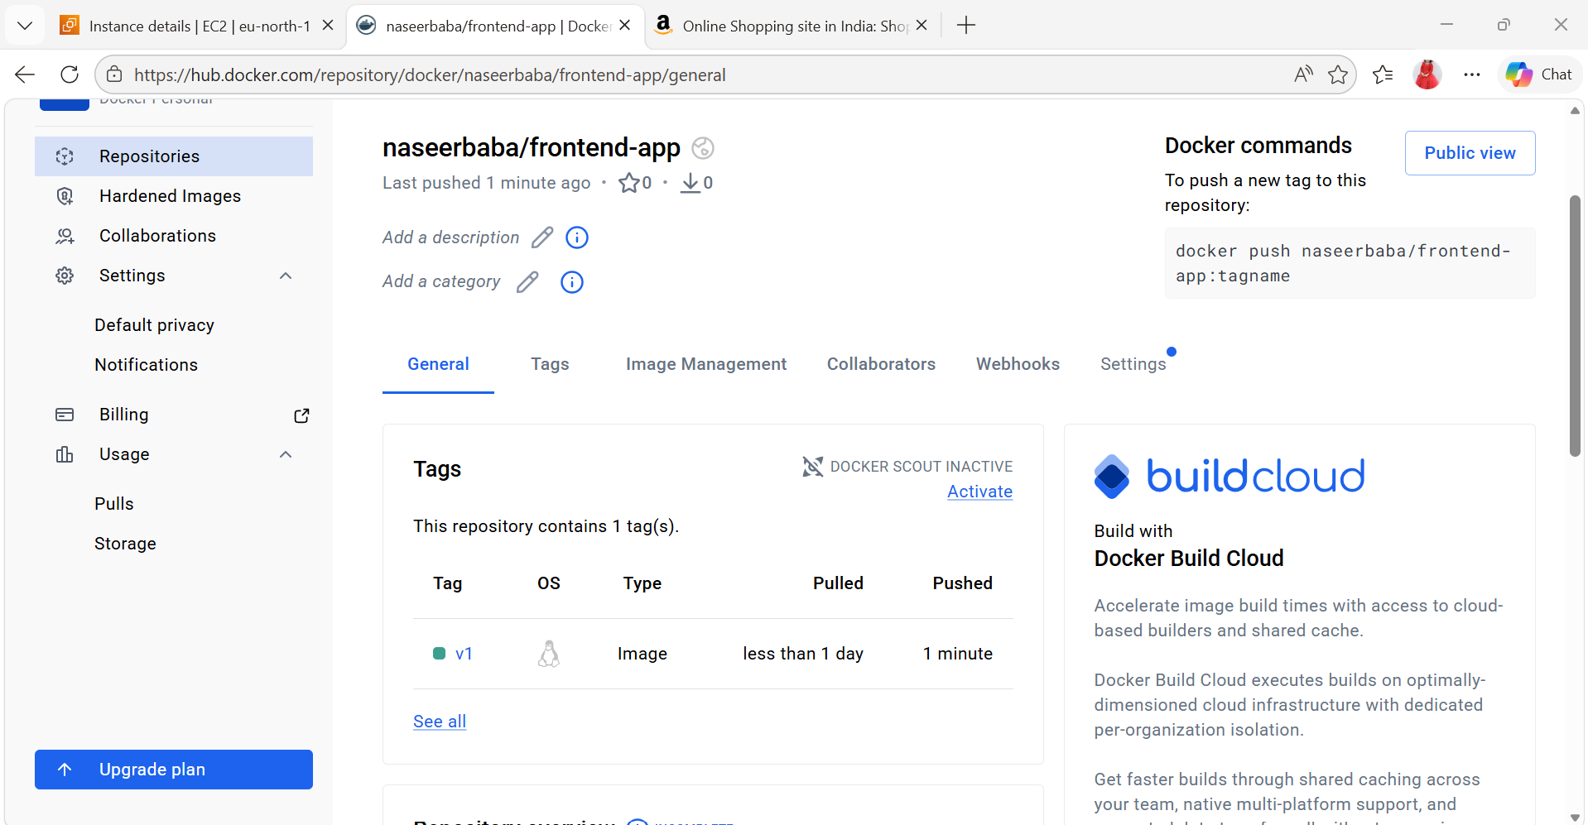
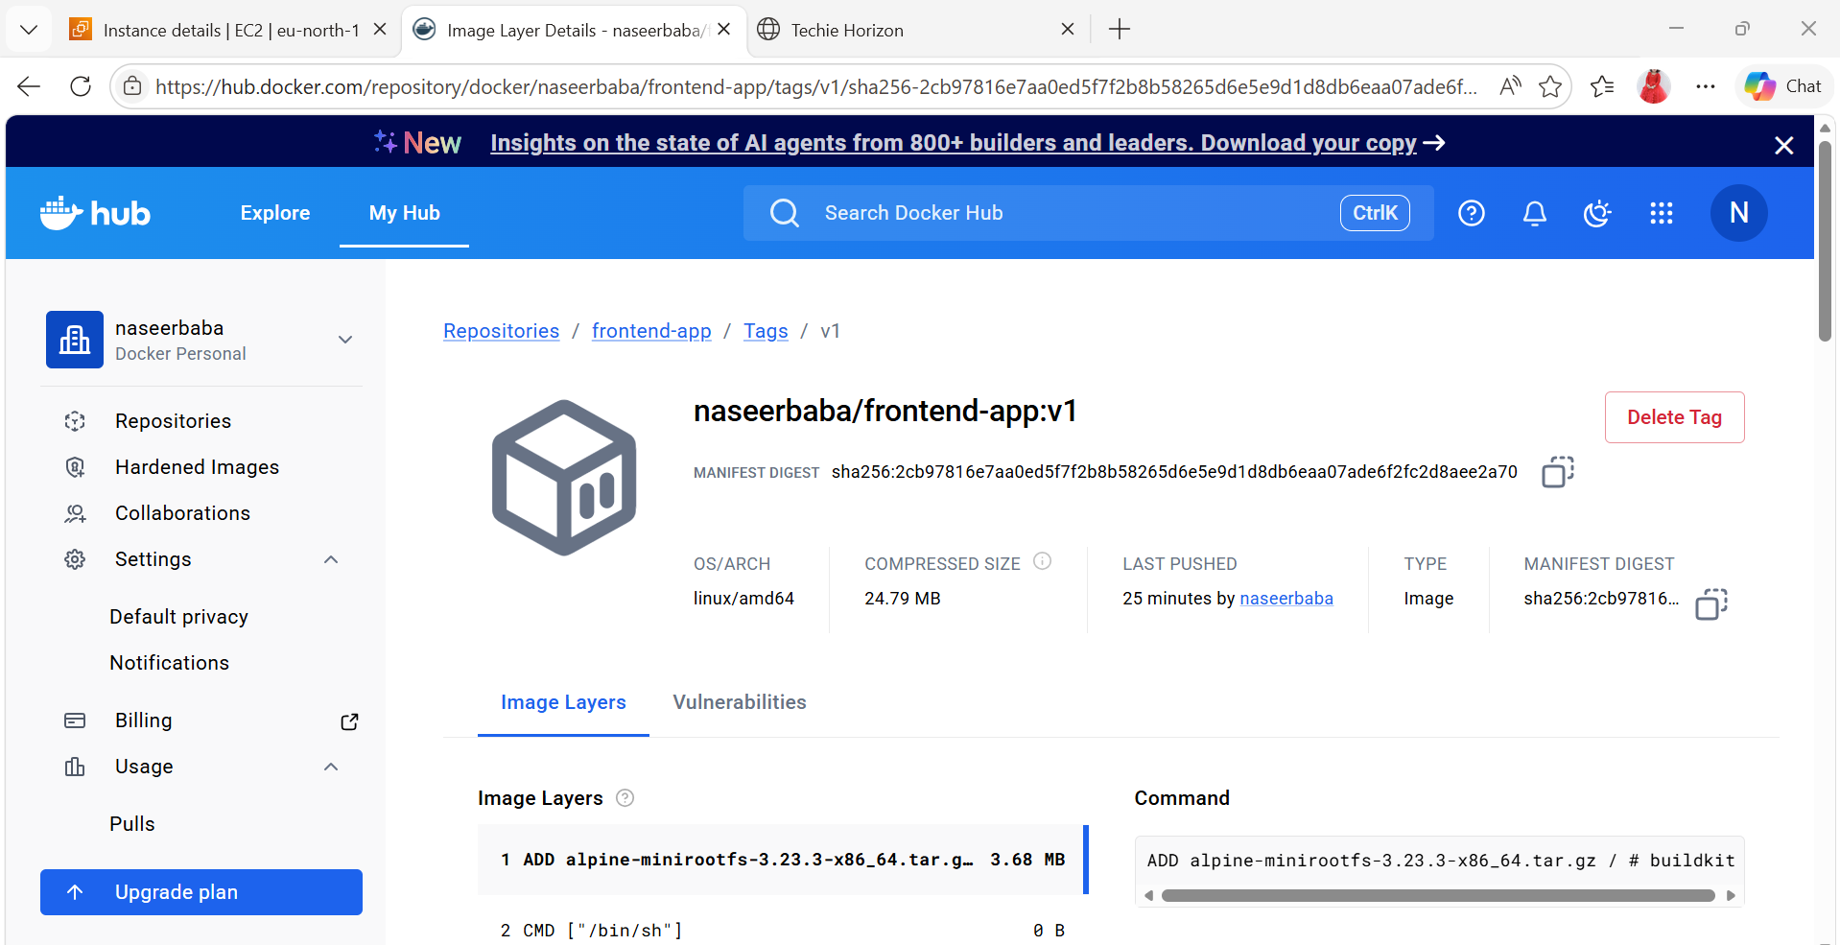
7). From the Java-based source code, write a Dockerfile, build, run, and push the image to the Docker registry.
- Build the image
git clone https://github.com/betawins/docker-tasks.git
cd docker-tasks/Java_based_source
Dockerfile
Create this file as:
docker-tasks/Java_based_source/Dockerfile
- Build the application
FROM maven:3.8.6-eclipse-temurin-11 AS builder
WORKDIR /app
COPY pom.xml .
RUN mvn dependency:go-offline
COPY src ./src
# Build jar
RUN mvn clean package -DskipTests
- Run the application
FROM eclipse-temurin:11-jre
WORKDIR /app
# Copy built jar from builder stage
COPY --from=builder /app/target/*.jar app.jar
EXPOSE 8081
docker build -t naseerbaba/java-spring-app:latest .
- Run the container
docker run -d --name java-spring-container -p 8081:8080 naseerbaba/java-spring-app:latest
Check it
docker ps
docker logs java-spring-container
On an EC2 server, open: http://13.60.105.21:8081
- Push to Docker Hub
First login:
docker login
Push the image:
docker push naseerbaba/java-spring-app:latest

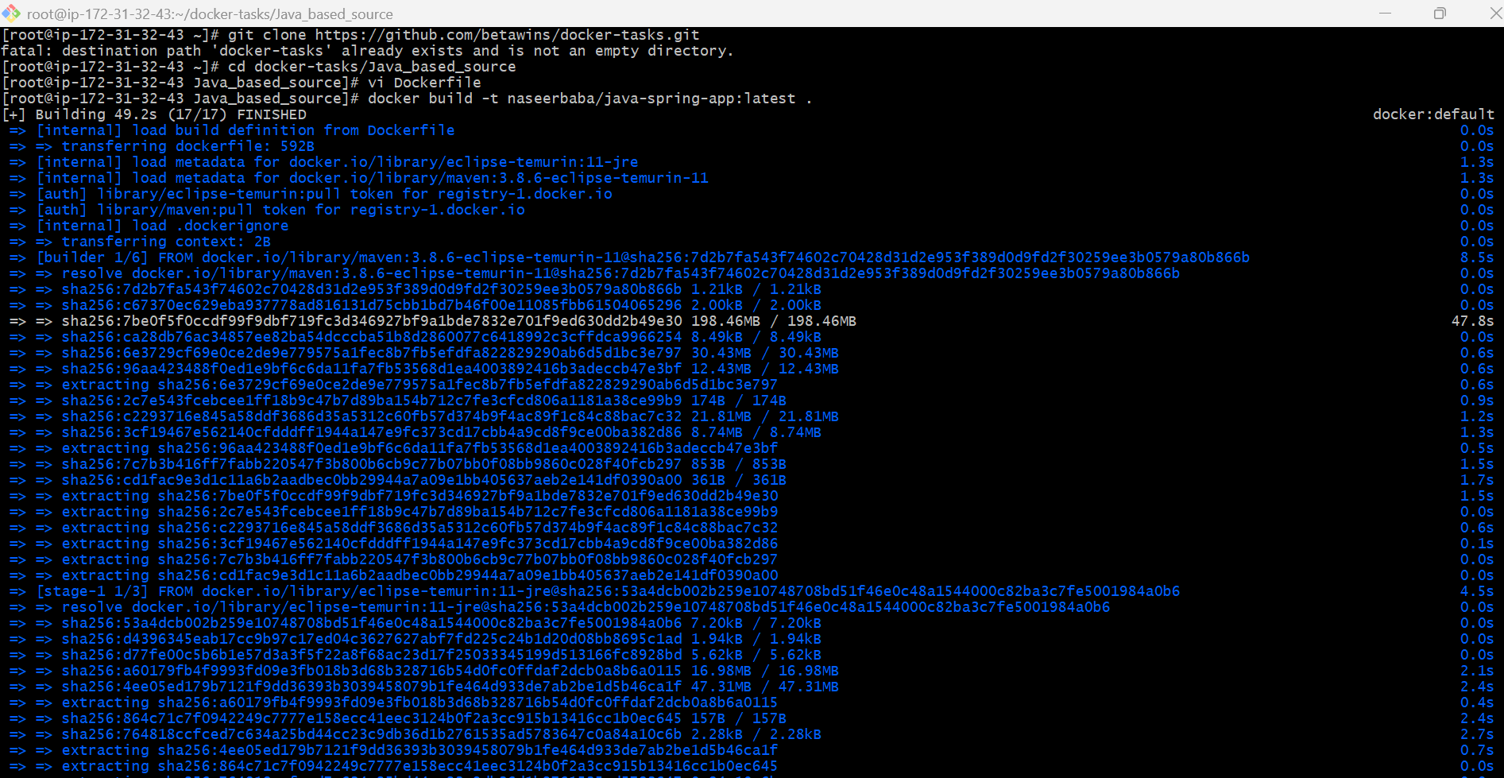
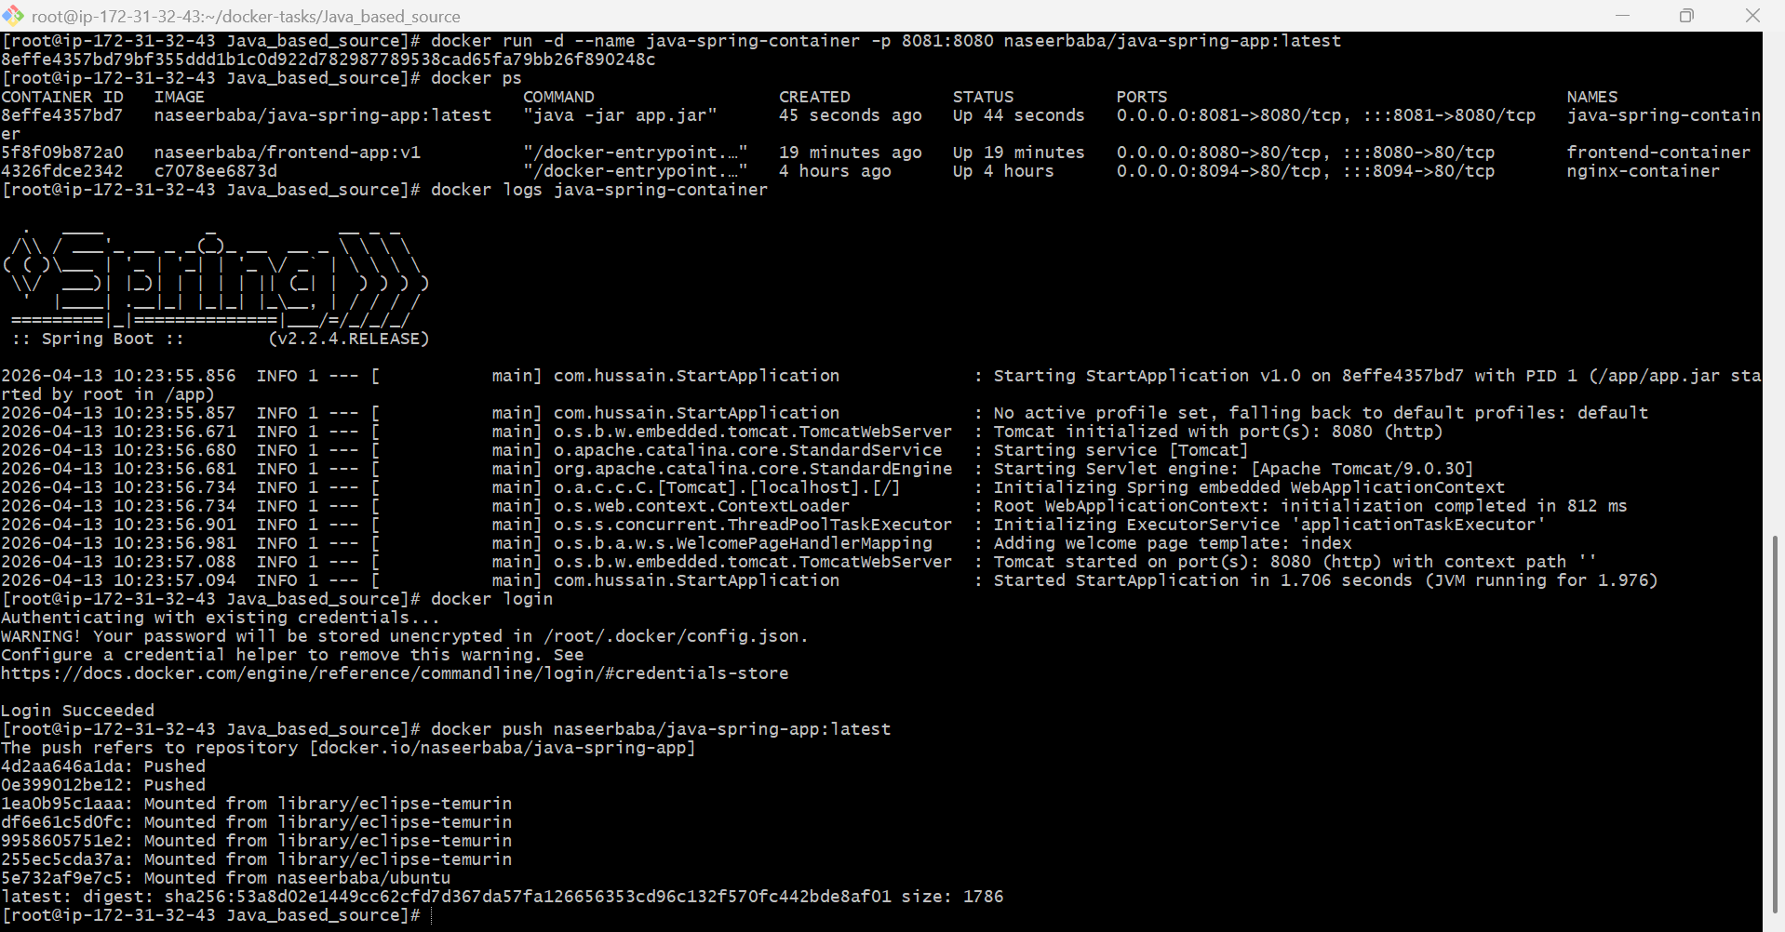

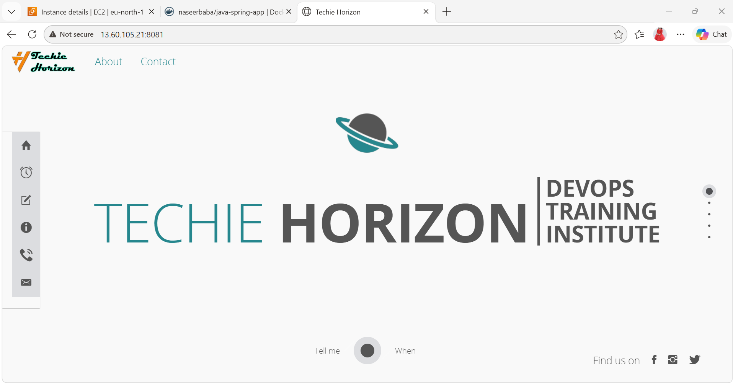
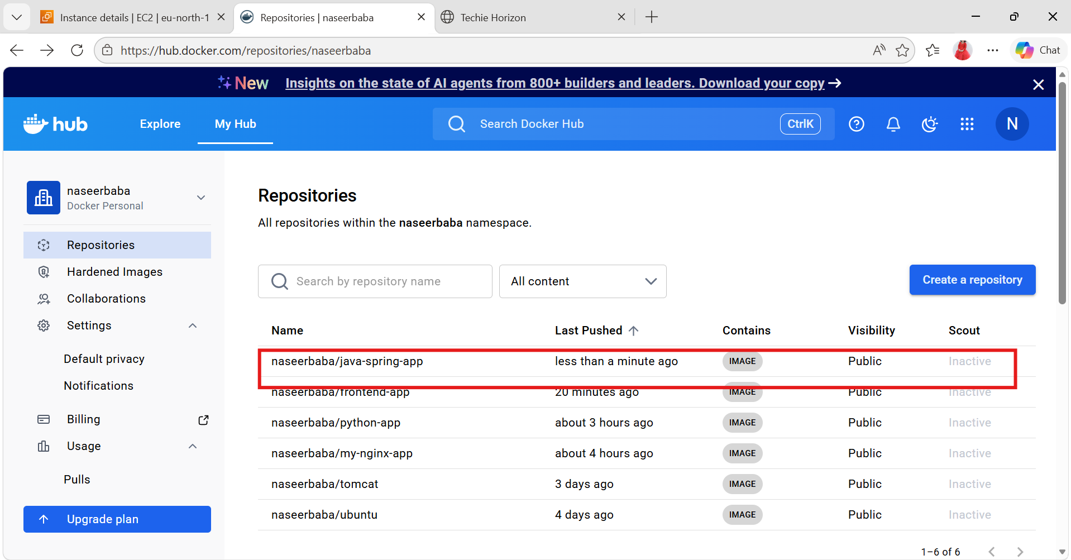

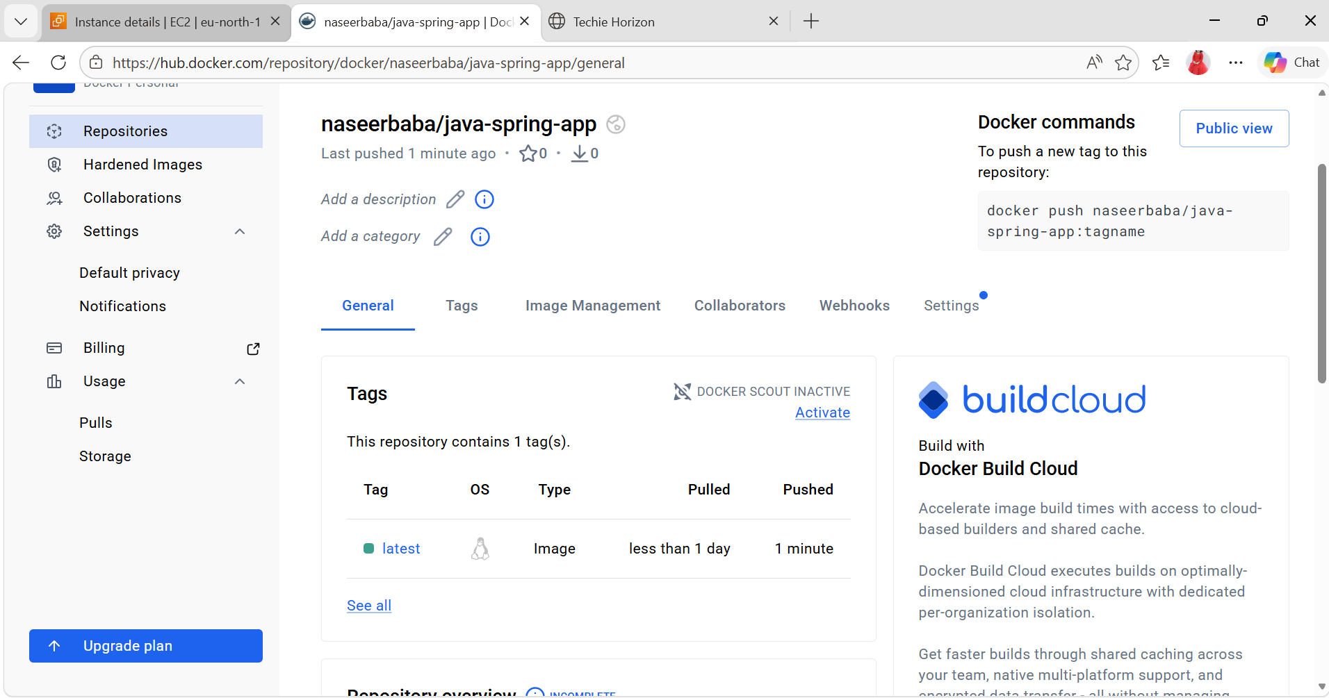
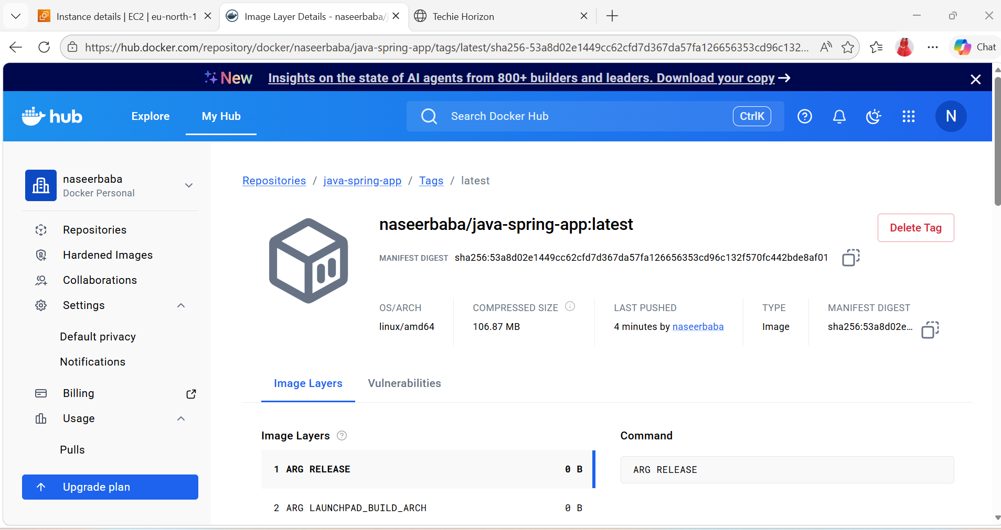
8). From the Node.js-based source code, write a Dockerfile, build with tag v1, run, and push it to the Docker registry.
- Build image with tag v1
git clone https://github.com/betawins/docker-tasks.git
cd docker-tasks/NodeJs_based_source
Dockerfile
Creace/Dockerfile`:
- Build the React app
FROM node:18-alpine AS builder
WORKDIR /app
# Copy dependency files first
COPY package*.json ./
# Install dependencies
RUN npm install
# Copy source code
COPY . .
# Build production files
RUN npm run build
- Serve with Nginx
FROM nginx:alpine
# Remove default nginx static files
RUN rm -rf /usr/share/nginx/html/*
# Copy build output from builder stage
COPY --from=builder /app/build /usr/share/nginx/html
# Expose nginx port
EXPOSE 80
# Start nginx
CMD ["nginx", "-g", "daemon off;"]
docker build -t naseerbaba/nodejs-app:v1 .
Run the container
docker run -d --name nodejs-app -p 3000:80 naseerbaba/nodejs-app:v1
Open in browser: http://13.60.105.21:3000
Push to Docker registry
First log in:
docker login
Then push:
docker push naseerbaba/nodejs-app:v1
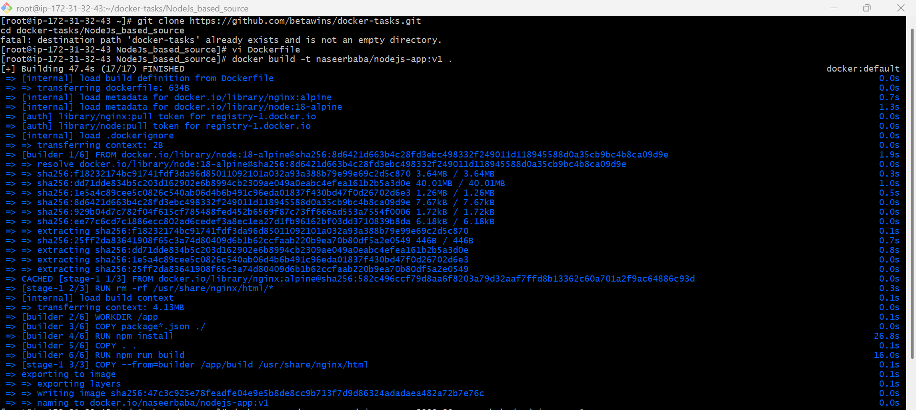
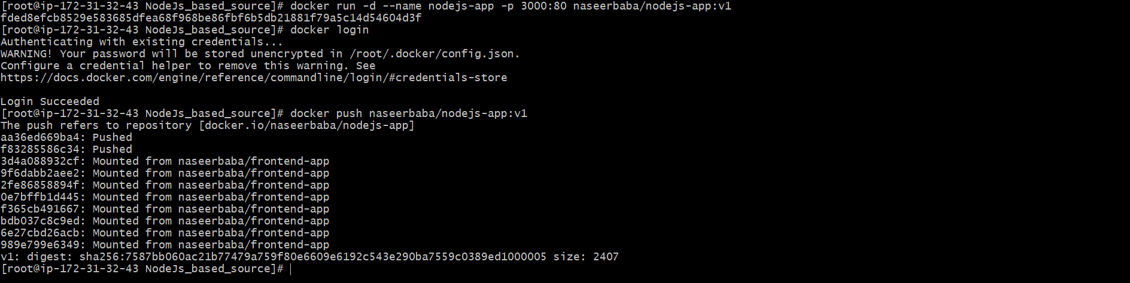


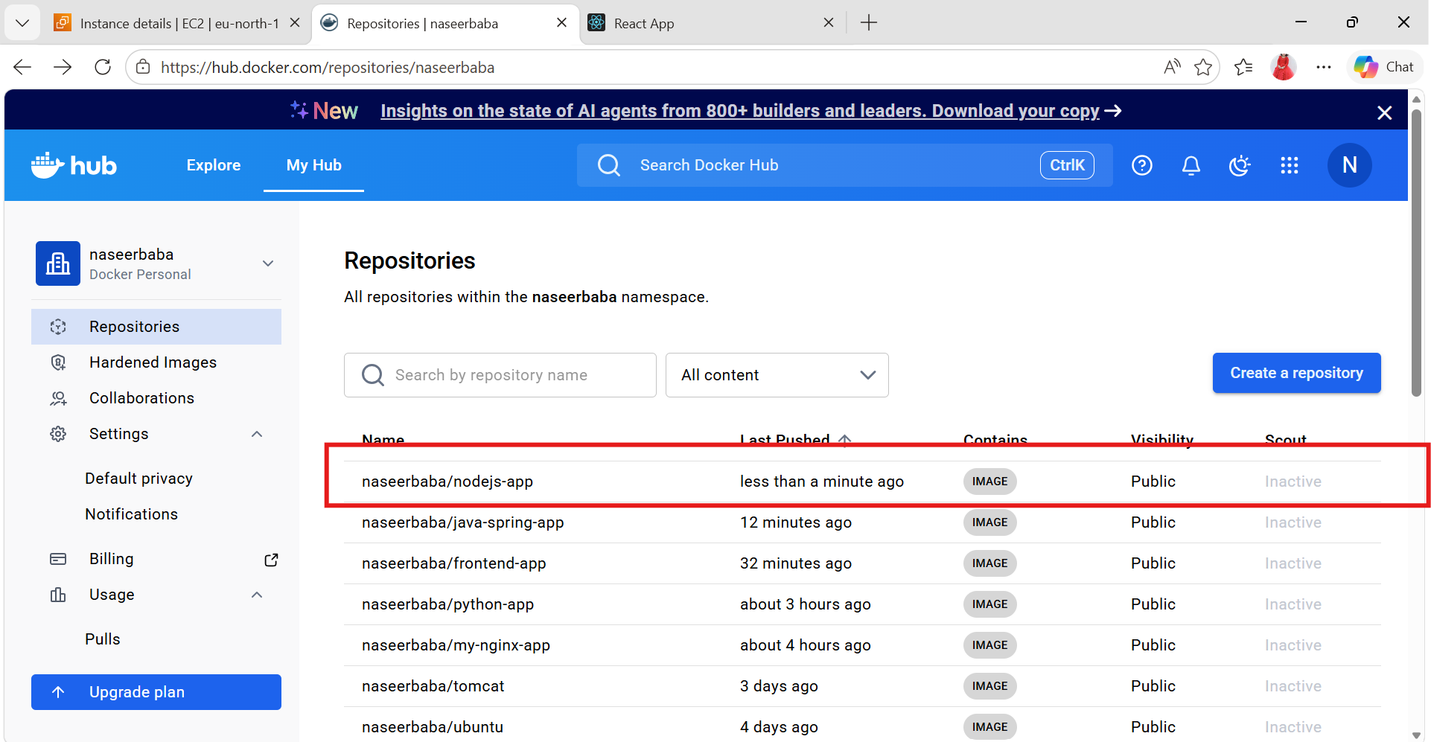
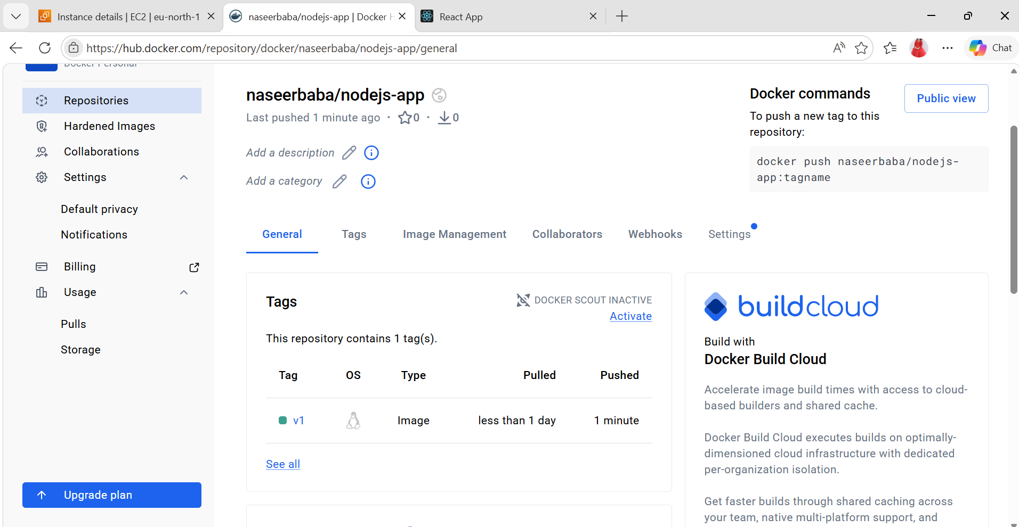

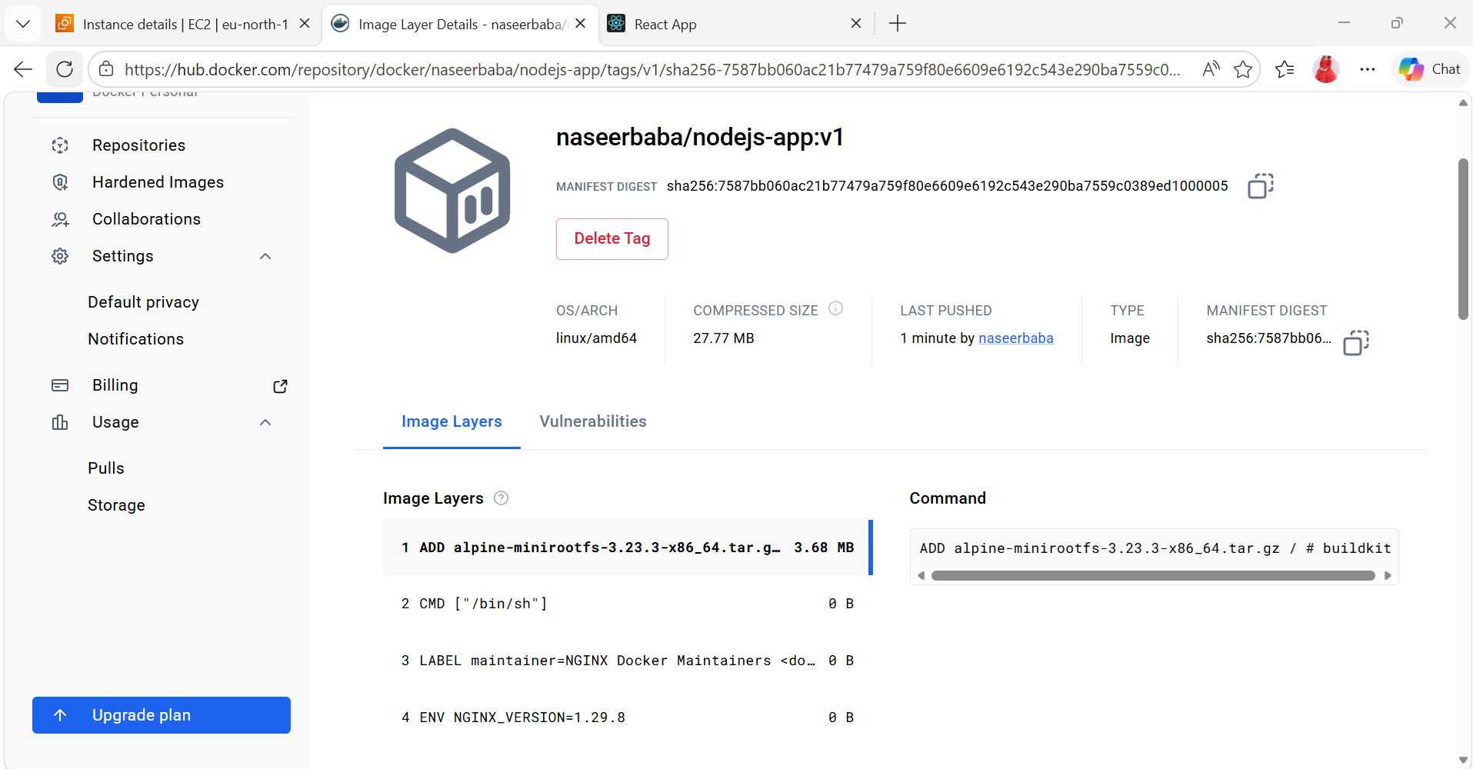

9). Write a docker-compose file to set up WordPress with a MySQL database.
Docker-compose file
- docker-compose.yml:
- version: '3.8'
services:
db:
image: mysql:5.7
container_name: wordpress-db
restart: always
environment:
MYSQL_DATABASE: wordpress
MYSQL_USER: wpuser
MYSQL_PASSWORD: wppassword
MYSQL_ROOT_PASSWORD: rootpassword
volumes:
- db_data:/var/lib/mysql
wordpress:
image: wordpress:latest
container_name: wordpress-app
depends_on:
- db
restart: always
ports:
- "8088:80"
environment:
WORDPRESS_DB_HOST: db:3306
WORDPRESS_DB_NAME: wordpress
WORDPRESS_DB_USER: wpuser
WORDPRESS_DB_PASSWORD: wppassword
volumes:
- wordpress_data:/var/www/html
volumes:
db_data:
wordpress_data:
- Save it as docker-compose.yml, then run:
- docker-compose up -d
- Open in browser:
- http://13.60.105.21:8088
